**CLorox Data Migration Tool**

Design Document



**Revision History**

|  |  |  |  |  |  |
| --- | --- | --- | --- | --- | --- |
| **S.No.** | **Version Number** | **Date** | **Revision Author(s)** | **Reviewers** | **Summary of Changes** |
| 1 | 1.0 | 22-Jan-19 | Ranjani |  | Initial Draft Design |
|  |  |  |  |  |  |

Table of Contents

1 Introduction 4

1.1 Purpose 4

1.2 Scope 4

1.3 References 4

1.4 Overview 4

1.5 Terminology 4

1.6 Performance Considerations 4

1.7 Design Goals 4

1.8 Introduction 4

1.9 High level Design Architecture 5

1.9.1 Functionality 5

2 Technical Design 5

2.1 Data Extraction 5

2.2 Pre-Migration Tasks 6

2.3 XML Transformation 6

2.4 Post- Migration Data Correction 6

2.4.1 Data Mapping 6

2.5 XML Loading 6

3 Techonologies 6

3.1 VBA Macro 6

3.2 TCL 6

3.3 Java 6

4 Steps to Run MigrationTool 6

4.1 Macro for Substance 6

4.2 Macro for Specification 6

4.3 Macro for Raw Materials 7

4.4 Macro for Recipes 7

4.5 TCL for ECM creation 7

4.6 Start Migration 7

# Introduction

## Purpose

The purpose of this document is to provide low-level design of the system. The document provides information on components and their interactions, also the architectural decisions to serve as evidence that the designers are following through on their commitment to implement the functionality described in the requirements specification. This document serves as training material for future development with enough information and understanding about the project implementation.

## Scope

This document provides overview of the technologies used, design and the interaction between the components for the Data Migration Tool.

## References

## Overview

This section would give a brief insight of what has been covered in the document.Design Goals section describes about the components and APIs that need to be developed.Technical Design Section gives an idea about the High level Technical architecture of the tool , Class diagrams and brief about some of the important classes in the Tool. Technologies section covers about the technogies that are being used during the Data Migration tool Development

## Terminology

PLM- Product LifeCycle Management.

## Performance Considerations

## Design Goals

Developing a VBA Macro migration tool to migrate data from multiple non-PLM systems to the 3D Experience system.

## Introduction

The Data Migration Tool should be developed in such a way that it incorporates the following features and functionalities:

1. Should be Platform independent.
2. Should be capable of handling large volumes of data.
3. Designed to handle wide variety of data models.
4. Designed in such a way that it should be able to run two or more XML generation.
5. Should be capable of handling Exceptions during Data migration.

## High level Design Architecture

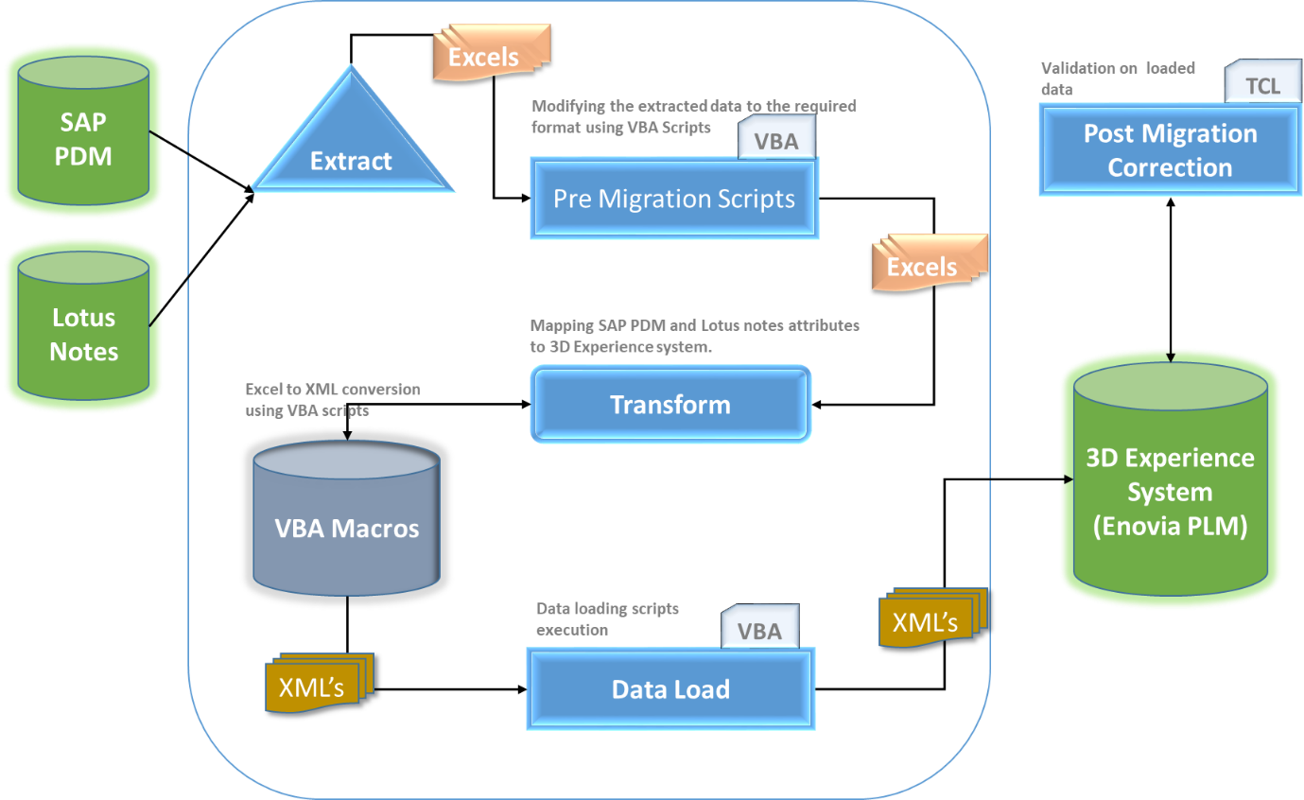

### Functionality

As shown in the above Design Architecture , There are Three main phases in the Migration tool. Those are Extraction, Transformation and Loading. The Extraction will be done by SAP team and the data will be given to us in excel format. These Excel will go through the Pre migration phase where we have a VBA scripts to enhance the extracted data for xml generation. Transform phase is responsible for Transforming Excel data into XMLS. The generated XMLS will be stored in defined local path. Once the XML is generated the next phase is Post Migration Correction here validation and mappling rules will be done for the XML’s for Production data Load. In Loading phase the XMLS will be loaded into the Target system called 3D Experience system (Enovia PLM) using the TCL scripts for data Loadiung.

# Technical Design

## Data Extraction

## Pre-Migration Tasks

## XML Transformation

## Post- Migration Data Correction

### Data Mapping

## XML Loading

# Techonologies

## VBA Macro

VBA, which stands for Visual Basic for Applications, is a programming language developed by Microsoft VBA is the tool that people use to develop programs that control Excel. You can record a macro while you perform the task on the first workbook and then let the macro repeat your action on the other workbooks.By developing a macro that combines these commands into a single custom command, which you can execute with a single keystroke or button click.

## TCL

Tool Command Language/Tool Kit (Tcl/Tk ) is a scripting language for coding embedded applications. Writing applications that can be extended by users and modified quickly. Tcl is particularly used to create GUIs, and management and integration tools for mixed environments including Windows, Unix and Linux.

## Java

Programming language to implement core Bussiness logic for the migration tool.

# Steps to Run MigrationTool

The Macro’s mentioned in the below steps can be executed from excel where the extracted data is present.

## Macro for Substance

Click on the **Transform** button to run the Macro for Substance

The XML’s will be stored in the path: **C:\Users\si259121\Desktop\Macro\Subs**

## Macro for Specification

Click on the **Transform** button to run the Macro for Specification

The XML’s will be stored in the path: **C:\Users\si259121\Desktop\Macro\Spec**

## Macro for Raw Materials

Click on the **Transform** button to run the Macro for Rawmaterial

The XML’s will be stored in the path: **C:\Users\si259121\Desktop\Macro\Rawmaterials**

## Macro for Recipes

Click on the **Transform** button to run the Macro for Recipes

The XML’s will be stored in the path: **C:\Users\si259121\Desktop\Macro\Recipes**

## TCL for ECM creation

Login to the MQL and switch to Tcl mode to run the tcl script for ECM creation.

Set the ECM creation TCL script path in tcl mode.

Execute the tcl command to run the script:

**TCL Command :** run ECMcreation.tcl;

Log file will be recorded on the failure /error .

## Start Migration

All the transformed xml will be stored in the defined path as mention earlier.

Run the TCL to execute all the XMLs in the path.

**TCL Command** : run dataload.tcl;

This will start execute all the xmls in the defined path. The above command starts the Data loading into the Target 3D Experience system (Enovia PLM).